PROPERTY BUYING & RENTAL SYSTEM
Aim:
To develop a simple Property Buying & Rental System for Chennai City using Zoho Creator to demonstrate the Software as a Service (SaaS) model, enabling users to search and register properties for buying or renting through a cloud-based application.
Procedure:
1. Log in to Zoho Creator and create a new application named Property Buying & Rental System.
2. Create a form and add the required fields such as Customer Details, Buy/Rent, Property Type (Residential/Commercial), Area, Place, Budget Range, Property Value, Rental Agreement, and other property details.
3. Configure field properties and create basic workflows for Buy/Rent and Residential/Commercial options.
4. Save the form, enter sample property records, and verify the generated reports.
5. Publish the application to demonstrate cloud-based access using the SaaS model.
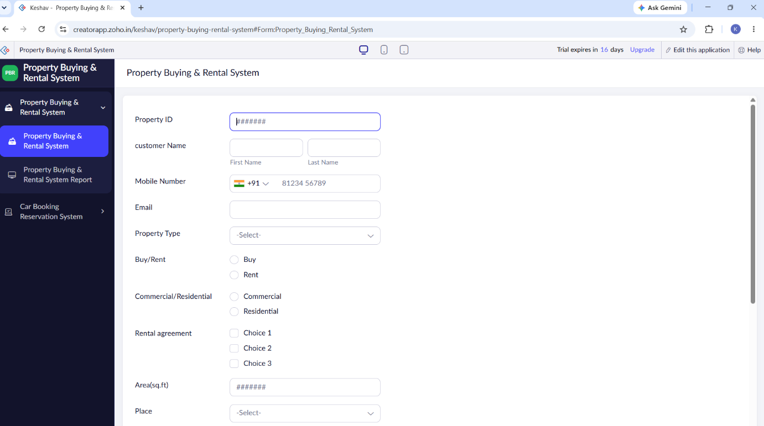
INPUT:

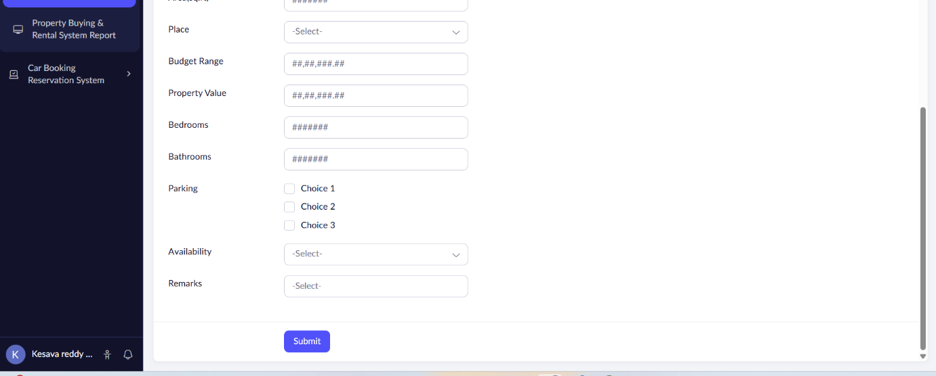
OUTPUT:
